Assignment 2

*Name: Muhammad Maaz Khan*

*Class: Se-5B Roll: Se-221053*

*Course:* ***Computer Networks***

*By* ***Sir Wilayat***

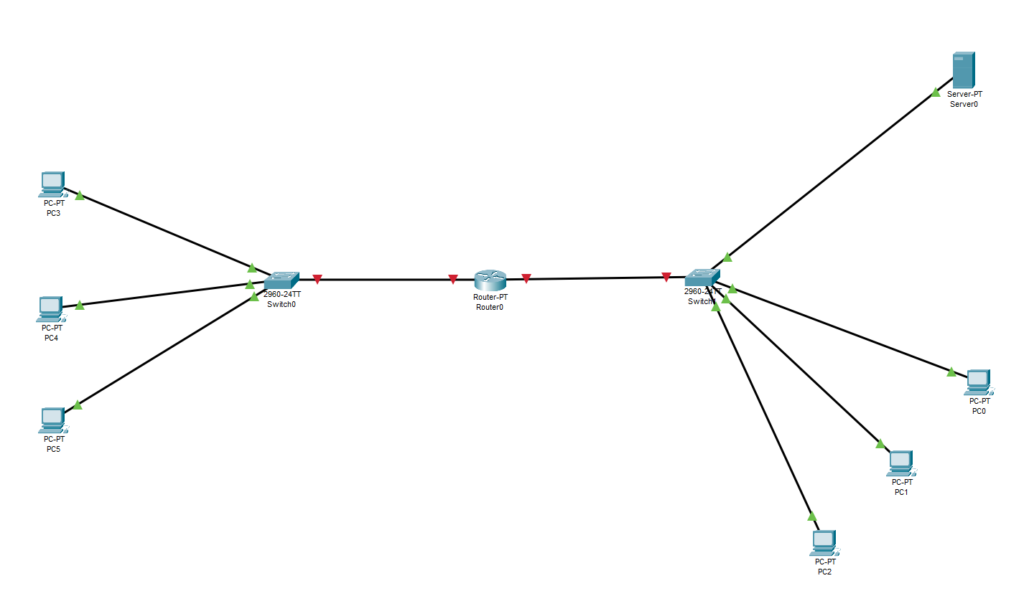  
  
***Adjusting the Topology***I connected two switches, one router, one server, and three PCs. The PCs are connected to the switch using copper straight-through cables.  
  
  
  
Their Link is Down (RED).  
  
  
***Configure the Router***  
  
  
Configure the Interface Connected to Switch1 (FastEthernet 0/0):  
  
  
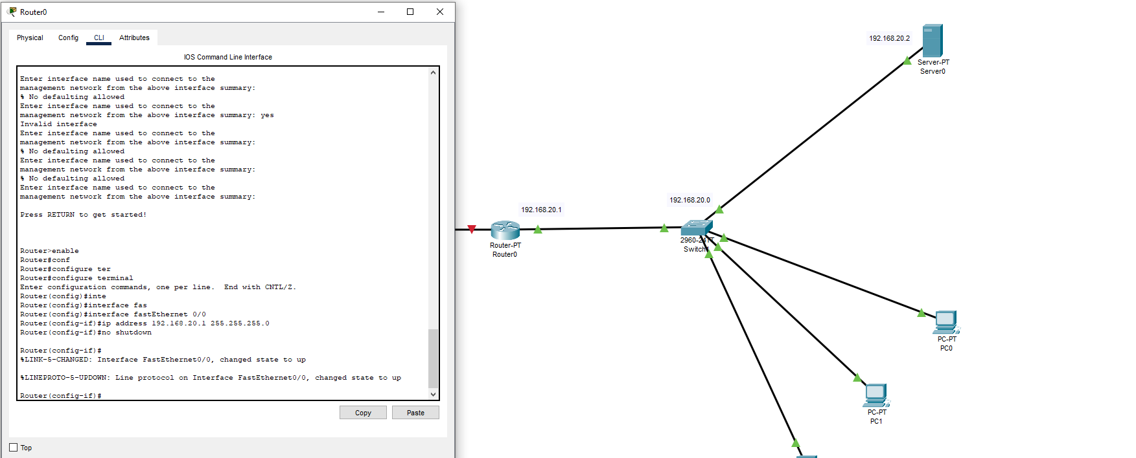  
  
  
  
  
  
  
Configure the Interface Connected to Switch0 (FastEthernet 0/1):  
  
  
  
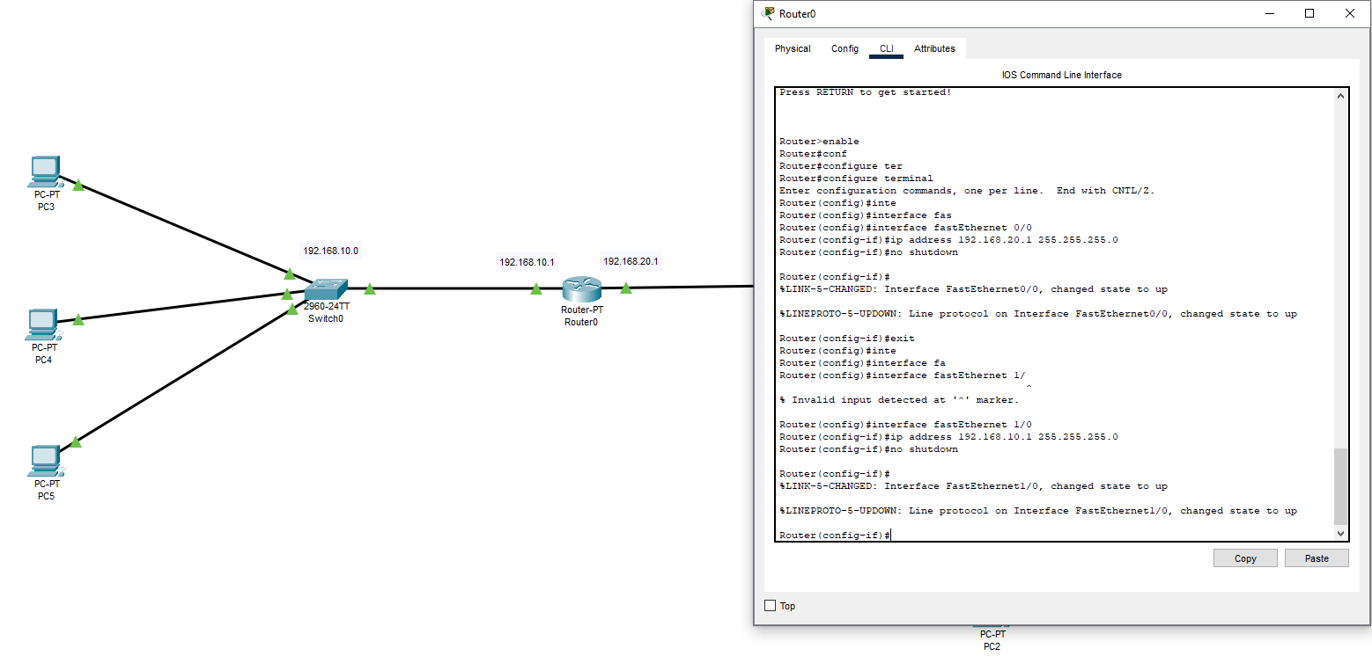  
  
  
  
ds

Set the Router as a DHCP Relay:  
  
  
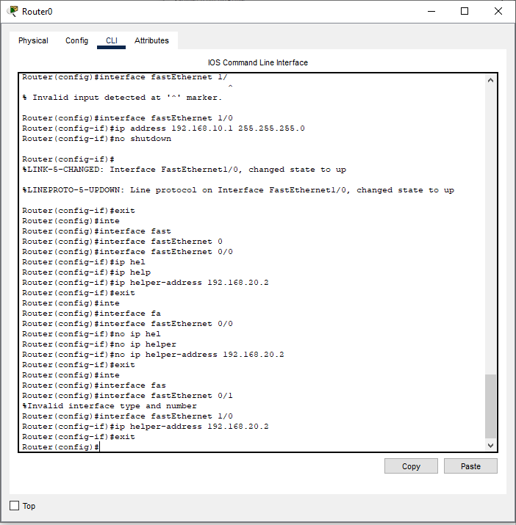  
  
  
  
  
  
  
**192.168.20.2** is the static IP address of the DHCP server.  
  
The router is configured with two interfaces, each assigned to different subnets: 192.168.10.0/24 for clients connected to Switch0, and 192.168.20.0/24 for the DHCP server and clients connected to Switch1. The ip helper-address command on FastEthernet 1/0 is used to forward DHCP requests from clients in the 192.168.10.0/24 subnet to the DHCP server at 192.168.20.2. This setup enables dynamic IP assignment across both subnets.  
  
  
Configure the DHCP Server:  
  
  
Once the router configuration is complete, proceed to the DHCP server setup.

Assign a static IP address to the DHCP server within the **192.168.20.0/24** subnet.  
  
Example: **192.168.20.2/24**

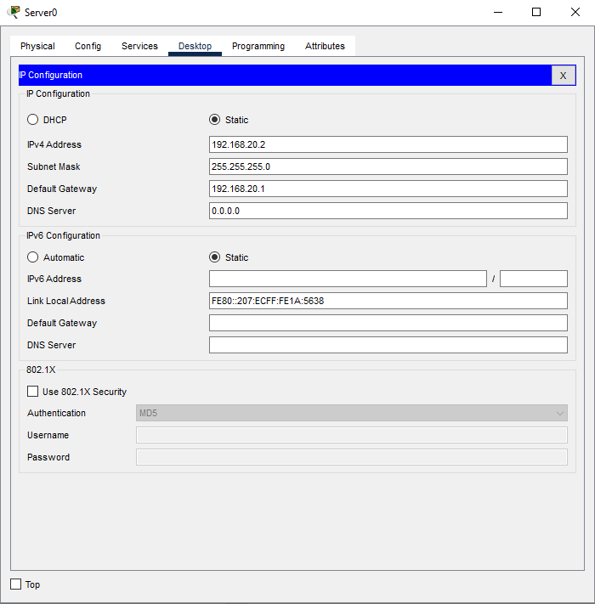  
  
  
  
  
  
  
  
  
  
  
For 192.168.10.0 Network

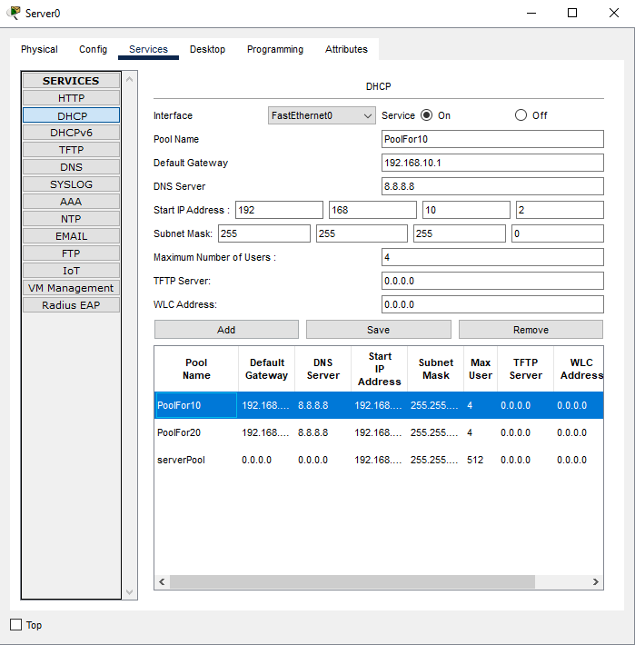  
  
  
  
  
PC’s  
  
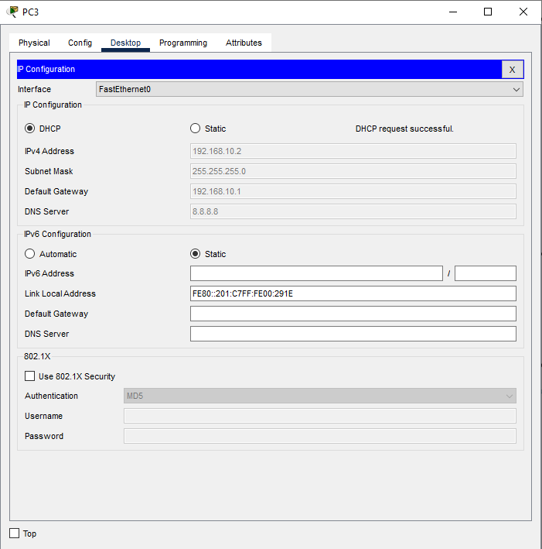  
  
  
  
  
  
  
  
  
  
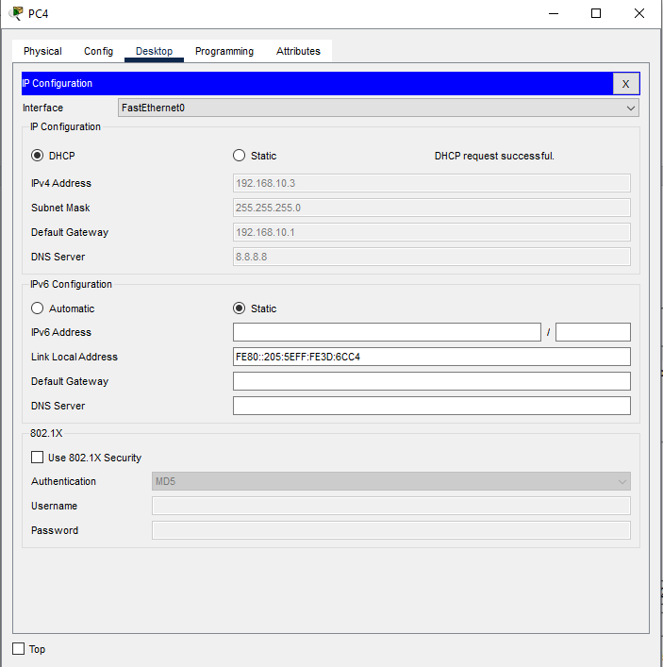  
  
  
  
  
  
  
  
  
  
  
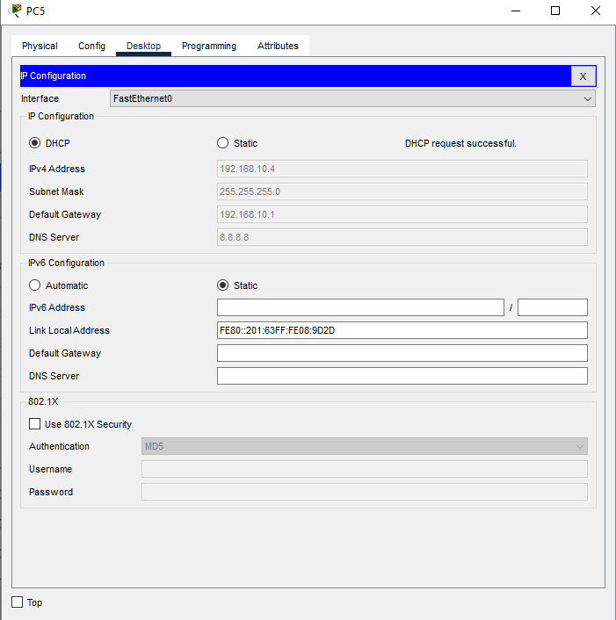  
  
  
  
  
  
  
For 192.168.20.0 Network.  
  
  
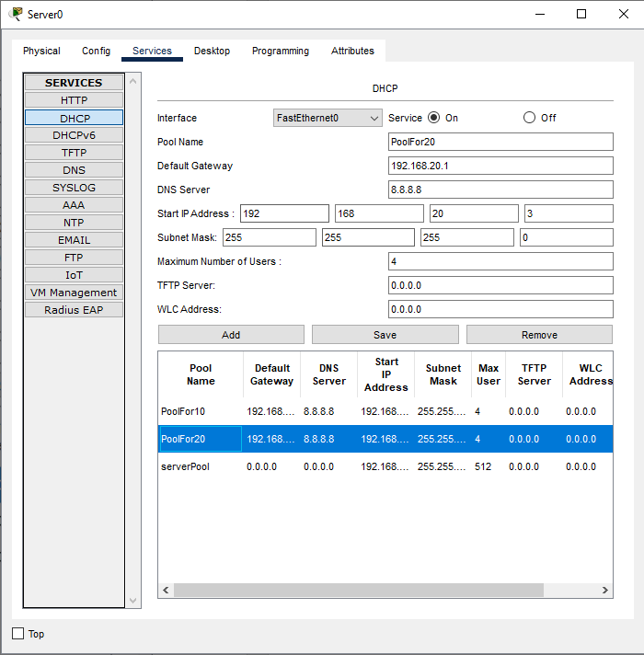  
  
  
  
  
  
  
Pc’s  
  
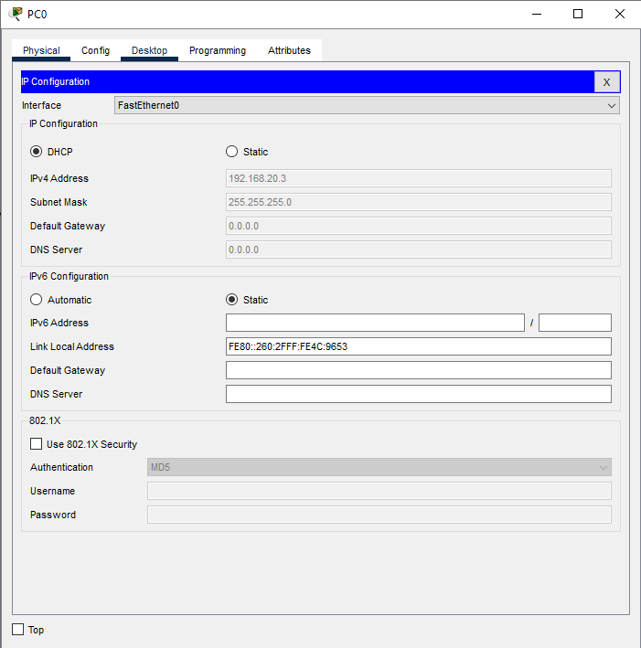  
  
  
  
  
  
  
  
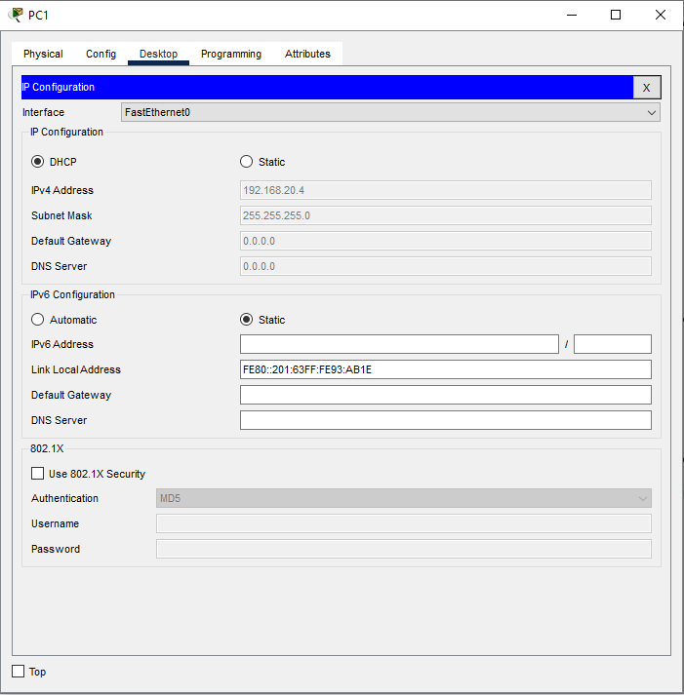  
  
  
  
  
  
  
  
  
  
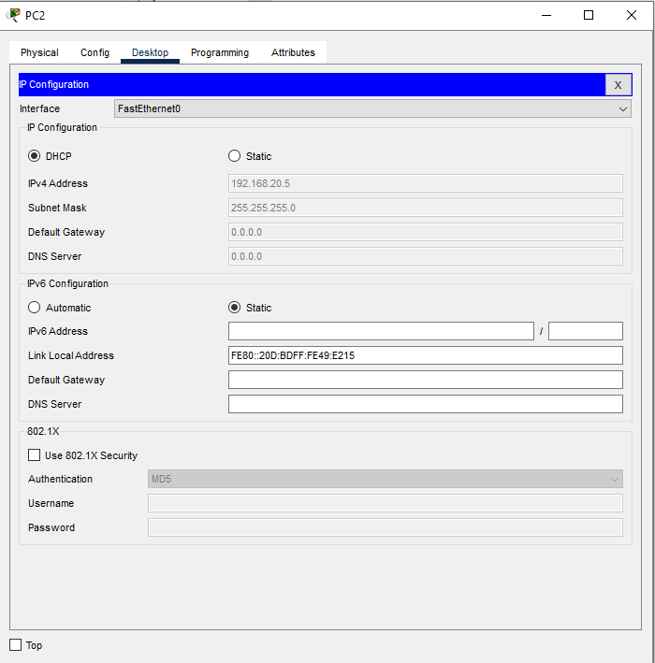  
  
  
  
  
  
  
  
  
  
The DHCP server successfully assigned IP addresses to PCs in two subnets: **192.168.10.0/24** and **192.168.20.0/24**. The router served as a DHCP relay for the 192.168.10.0/24 subnet, forwarding requests to the central DHCP server. Proper configuration of DHCP pools on the server ensured correct IP allocation, though minor adjustments to the gateway and DNS settings for PoolFor20 are needed for complete configuration.  
  
  
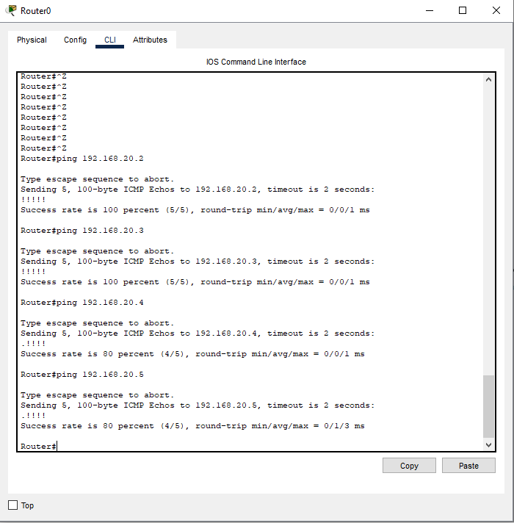  
  
The successful **ping results** confirm that the **router's configuration is correct**